**Bioregional Portrait**  
Nate Bachmeier  
Oct. 17th, 2014

Biology 100: Introductive Survey  
Bellevue College  
Facilitator: Kathy Steinert-Eger

**Table of Contents**

Bioregional Portrait 4

Describe exactly where you live. Draw a map if you like. 4

What is a watershed? In which watershed do you live? This means your own personal watershed according to the biological definition - do not ask the local water utilities for the name of your watershed. 5

Name five trees in your area, (within one or two blocks of your house). Which ones are native? 5

Name five resident plus any three migratory birds in your area. 6

Where is your local water supply stored? Look around your neighborhood for the nearest water tower or reservoir. 6

Where does your wastewater go and what happens to it along the way? When you flush your toilet what happens to it? Where are the pollutants removed? Is primary, or secondary, or tertiary treatment done there? 7

You've changed the oil in your car and now you need to get rid of the old oil. How do you do that in a way that is safe and environmentally sound? Be specific in your answer. 8

What was the area you live in like 50 years ago? 100 years ago? 150 years ago? 200 years ago? Include people, places and nature in your description. What what was happening to the Indigenous Peoples of your Bioregion during each time period? What is their role in your Bioregion during these four time frames? 8

Name some beings (nonhuman) which share your place. Include both wild and domestic beings. 9

What type of energy do you use to heat your house, from where does this energy come? What environmental effects does this type of energy have? 9

Name the nearest creek or stream to your home, and trace its passage from source to outlet. Include above and below ground portions. 9

List the nearest local, and state, and national park to your house, what kinds of activities are allowed in each of these (hunting, fishing, camping, motorcycling, horseback riding etc.). 10

Bibliography 11

# Bioregional Portrait

## Describe exactly where you live. Draw a map if you like.

I live in a bubble free of fresh air, only seeing the outside for a couple of moments each day. It always a constant temperature, with the same sterile feeling everywhere. From the outside there is always storm clouds but it is never misting. This can only be one place, Kirkland.

If I’m not there, then I’d be roughly in the top left corner of Kirkland. Rarely do I ever actually leave the quarantine zone. The most interesting part of this assignment is that I haven’t actually seen outside at any great length in such a long time it makes this kind of fun.

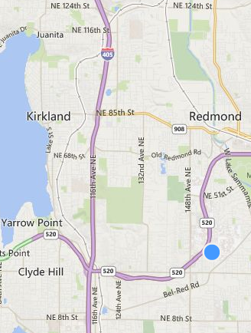

## What is a watershed? In which watershed do you live? This means your own personal watershed according to the biological definition - do not ask the local water utilities for the name of your watershed.

The assignment defined a watershed as the place where ‘water is shed’ from the main branch. This seems to be a general term that we are supposed to define as our place of residence. For me this would be the Forbes Lake (Microsoft), located to the north and west. This is based off of using Bing Maps and looking at the geographic area.

From other investigation there is evidence to suggest that “the South Fork Tolt River Watershed and the Cedar River Watershed (Kirkland Gov)” are the water sheds supplying the area.

## Name five trees in your area, (within one or two blocks of your house). Which ones are native?

I live in a condo so there are no native trees within the surrounding area, they have been replaced by Japanese Maples and other shallow rooted trees. From attending HOA meetings this has been the norm as shallow rooted plants do not damage the sideway. If that isn’t selective evolution, not sure what is.

If we had natural trees they would probably include (King County):

* Big leaf Maples
* Bitter Cherry
* Black Cottonwood
* Black Hawthorn
* Cascara

## Name five resident plus any three migratory birds in your area.

Aside from Costco, I’ve never seen birds in the East Seattle area. The King County website says that a more attentive biologist would have noticed:

Resident (WA Birder):

* Waterfowl
* Gallinaceous Birds
* Pelican, Herons, Ibis
* Vultures
* Raptors

Migrant (King County ):

* Olive sided Flycatcher
* Yellow-Rumped Warbler
* Townsend Warbler

## Where is your local water supply stored? Look around your neighborhood for the nearest water tower or reservoir.

The water seems to come from the Cascade Water Alliance, which encompasses various local cities (Kirkland Gov). Kirkland Gov then went on to provide a nice map of all water towers in the area:

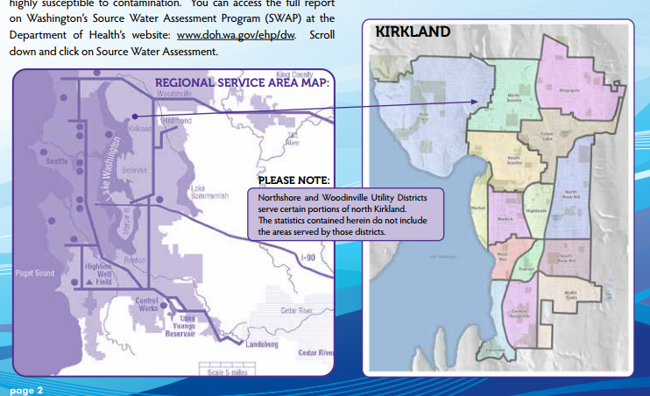

## Where does your wastewater go and what happens to it along the way? When you flush your toilet what happens to it? Where are the pollutants removed? Is primary, or secondary, or tertiary treatment done there?

The waste water goes to the “Wastewater Division of Public Works” which has been a black box up to this point (Kirkland Sewer). It turns out that this is collected at a pump station in downtown Kirkland (Kikrland Environment). The same pump station is also my bus stop, never noticed that. From there it goes to Renton and back.

I was unable to find information on water pollution; perhaps that means it’s safe to drink the water. There was information on the pollution index (Clr Search); which is shown below. They pointed suggest that most pollution in the air is above norm for America.

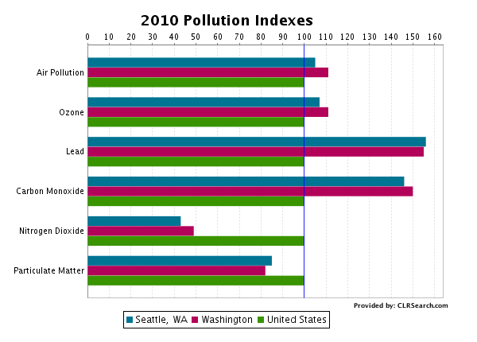

## You've changed the oil in your car and now you need to get rid of the old oil. How do you do that in a way that is safe and environmentally sound? Be specific in your answer.

I drive to Jiffy Lube, give the guy 20$ and 15 minutes later he returns my keys. They probably mix it with other oil and sell it back to us. Or perhaps they take it to Waste Management. This is the default pick for my HOA when it comes to waste management. After that is probably a trade secret.

## What was the area you live in like 50 years ago? 100 years ago? 150 years ago? 200 years ago? Include people, places and nature in your description. What what was happening to the Indigenous Peoples of your Bioregion during each time period? What is their role in your Bioregion during these four time frames?

The Kirkland area dates back to the late 1890s (Kirkland Heritage Society) with a very small population, barely reaching 250 by the 1910s (Wikipedia). Before that was indigenous people, and Seattle believes in celebrating them (ABC News); though not celebrating enough to explicitly name. After reviewing other sites (SIHB) and going to Alki Beach they are just native American. Later we politely asked them to return our land and tried to build saw mills (Wikipedia).

The local people were most likely a fishing colony. We can deduce this from their artwork (SIHB) and also the ocean is a close source of food. There is some evidence across these sites to suggest that open fields were here. After that was condos and mini marts.

## Name some beings (nonhuman) which share your place. Include both wild and domestic beings.

There is a pug Chihuahua that shares my place, she is pretty domestic as far as dogs go. When I go outside there are squirrels, raccoons, bats, pigeons, snakes, skunks, wood chucks, fox, coyote, and even armadillos (US Animal Control). I’ve never seen an armadillo here, but the Internet is never wrong.

## What type of energy do you use to heat your house, from where does this energy come? What environmental effects does this type of energy have?

We use natural gas it comes from the stove and the water heater. From investigating further there is evidence to suggest this comes from Washington Natural Gas.

According to the EPA, “natural gas produces nitrogen oxides and carbon dioxide (EPA).” This is interesting as the graph discovered for question #6 showed an abnormally high nitrogen oxide levels. Neat, these might be related.

## Name the nearest creek or stream to your home, and trace its passage from source to outlet. Include above and below ground portions.

Water comes through Union Bay into Lake Washington. From here it flows through Kenmore, Bothell, Woodinville, and down paste Redmond into Lake Sammamish. This is highlighted on the following map.

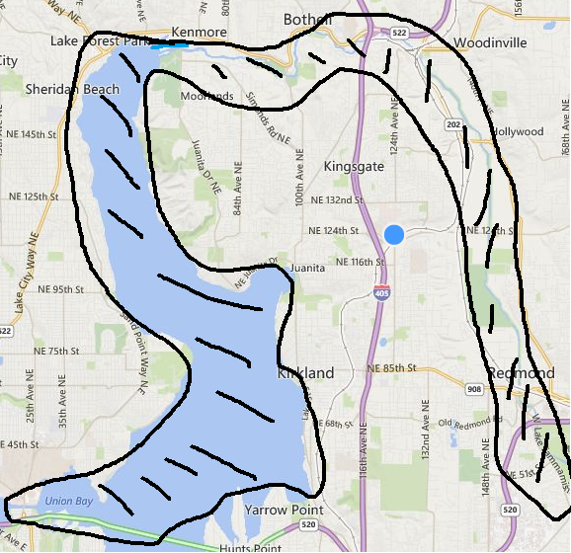

## List the nearest local, and state, and national park to your house, what kinds of activities are allowed in each of these (hunting, fishing, camping, motorcycling, horseback riding etc.).

The nearest national park is “Olympic National Park” this is located to the south and west. I’ve stayed there, they did not let us RV only tent camping.

The nearest state park is Saint Edward State Park, located north of Juanita. They use this to hold beer festivals and similar events. You can’t sleep here unless you attended the beer festival.

The nearest city park is North City Park in Shoreline. They only allow camping to homeless and is intended for general walking around.

# Bibliography

ABC News. *Indigenous People Day Replaces Columbus Day*. 2014. <http://abcnews.go.com/US/wireStory/indigenous-people-day-replaces-columbus-seattle-26005980>.

Clr Search. *Seattle Pollution Indexes*. 2010. <http://www.clrsearch.com/Seattle-Demographics/WA/Pollution-Levels>.

EPA. *Natural Gas*. 2012. <http://www.epa.gov/cleanenergy/energy-and-you/affect/natural-gas.html>.

Kikrland Environment. *Kirkland Pump Station*. 2014. <http://www.kingcounty.gov/environment/wtd/Construction/East/Kirkland.aspx>.

King County . *Animals, plants and habitat*. 2014. <http://www.kingcounty.gov/environment/animalsAndPlants/biodiversity/defining-biodiversity/species-of-interest/birds.aspx>.

King County. *Native Plant List*. 2014. <https://green.kingcounty.gov/gonative/Plant.aspx?Act=list>.

Kirkland Gov. *Water Quality Report*. May 2014. <http://www.kirklandwa.gov/Assets/Public+Works/Public+Works+PDFs/Water/2014+Water+Quality+Report.pdf>.

Kirkland Heritage Society. *Preservation Begins at Home*. 2012. <http://kirklandheritage.org/research-sources/kirkland-history/>.

Kirkland Sewer. *Sewer & Septic*. 2014. <http://www.kirklandwa.gov/depart/Public_Works/Utilities/Sewer___Septic.htm>.

Microsoft. *Maps*. 2014. <http://www.bing.com/maps/#Y3A9NDcuNjM3ODIyfi0xMjIuMTMzMTczJmx2bD0yMCZzdHk9ciZxPW1pY3Jvc29mdCUyMGJ1aWxkaW5nJTIwNDE=>.

SIHB. *Seattle Indiginous Habitat Balony*. 2012. <http://www.sihb.org/indigenous-cultures-fair/>.

US Animal Control. *Kirkland Washington*. 2013. <http://www.usanimalcontrol.com/kirkland-washington-animal-control-removal-bat-skunk-raccoon-snake-wildlife-attic-walls-chimney-pest-rodent-rat-mice-opossum-deer-fecal-insulation-cleanout-colony-fox-cyote.html>.

WA Birder. *WA State List*. 2014. <http://www.wabirder.com/docs/WAState_list.pdf>.

Wikipedia. *Kirkland Washington*. 2013. <http://en.wikipedia.org/wiki/Kirkland,_Washington>.